Title

Clearing Outlook Address book cache

Prepared By
Systems Team

Date: 15-03-2019

Version 1.0

Document History

Date | Author | Revision | Description
15-03-2019 | Systems Team | Version 1.0 | Document Creation

Approved By: | Tata Business Support Services Limited
Harish Karan | Version 1.0

Distribution List
Name | Department | Company | Rights
Systems Team | Technology – Service Delivery | TBSS | Read and Modify
Harish Karan | Technology – Service Delivery | TBSS | Verify and Comment
Ali Hyder | Technology – Service Delivery | TBSS | Full and Approve

Security Classification: CBSL Restricted.

1. In the Outlook main window, click the File menu. From the File menu, click the Options button.

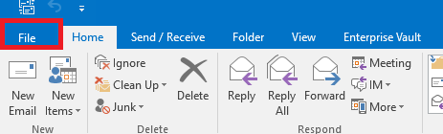

2. In the Options, click the Mail tab and browse to the Send Messages section. Click the Empty Auto-Complete List button.

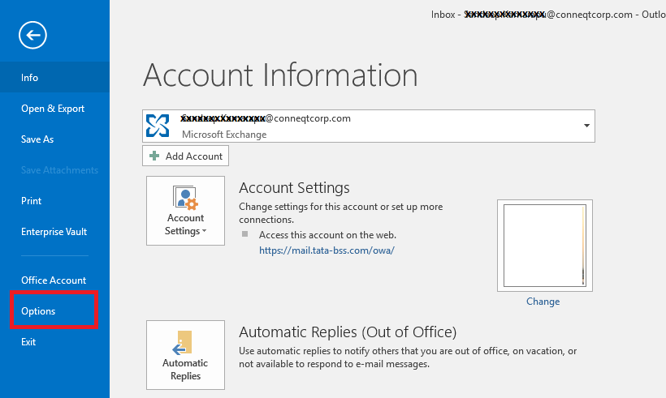
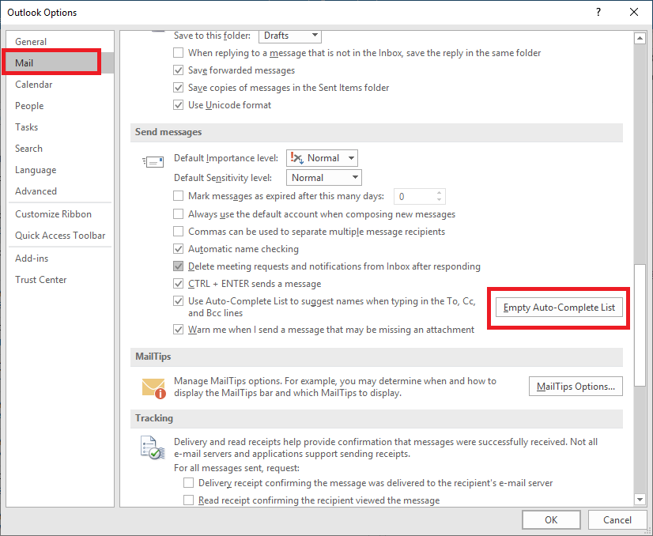
3. A confirmation box will appear, click Yes. The AutoComplete cache will be completely erased.

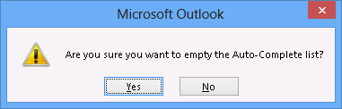

4. Close the outlook and type the below in “Run” window and delete the folders which is inside the “Offline Address Book” for Ms Office 2010 and 2013 Users and Stream files from “RoamCache” folder for 2016 Users
Path:
For MS Office 2010 and Ms Office 2013
%userprofile%\Local Settings\Application Data\Microsoft\Outlook\Offline Address Books
For Ms Office 2016
%userprofile%\Local Settings\Application Data\Microsoft\Outlook\RoamCache

5. Open Outlook and send email with recipient complete address in new email as shown in the screen shot.
